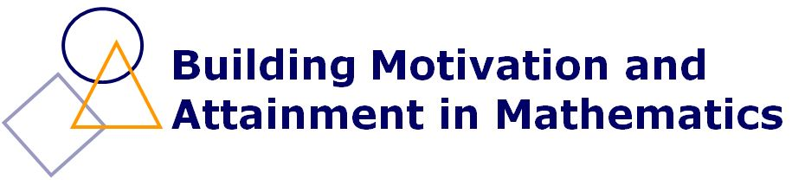
PGCE Maths Activity Day, March 2013
61 attendees in one group
Feedback from the attendees

1— I thought that this activity was
Excellent 47 Very good 11 OK/alright 0 not very good 0 poor 0

2— Please circle all words and phrases that describe how you feel about today’s activity

Enjoyable 56
Useful 55
Practical 46
Motivating 38
Boring 0
Informative 33
A waste of time 0
Too long 0
Challenging 22
Too short 12
Interesting 51
Reassuring 14

3 - The most useful thing I learned during this activity was:
All of it!
Folding shapes
How to bring paper-folding into the classroom
How to describe simple origami easily
How to make mathematics practical
The wealth of resources shared and ideas I have been given to use in my teaching
Learning various useful activities
How to apply fun activities to a learning outcome
The wide cross-section of pupils that you can engage with these activities
That simple multiplication in games improves mathematical thinking
Different maths activities
The advantage of using simple, easy to relate to activities
How to vary my lessons using cheap resources
Maths word search
Folding activity and loads of aspects of geometry
Good ideas about using pens as rewards
Paper-folding and making shapes
Making maths a more tactile experience
Good practical resources to engage pupils are very accessible
I like the clue cards and prizes idea
Pyramid and whole one search
Resources for shape and measure
How to make shape and space interesting
Know how to motivate students to get good responses
Phoebe’s number 24 game
24 game and ideas to adopt it
How to make maths competitive
Interesting ways of making shape and space visual and interesting for difficult classes
Being able to take activities that I can use in school after having the chance to do them
How to make shape and space more practical
Ideas for varied interactive tasks
How simple resources like paper can be used for interesting and effective learning
Variety of maths games to use in lessons
Folding shapes and how to use with a class
The maths origami taught me to think of kinaesthetic ways to teach geometry
I can create all the resources cheaply
Fantastic resources that I will be able to use with a variety of classes
Paper-folding – going to use tomorrow
Ways to challenge and motivate all learners
How much you can do with A4 paper
There are loads of great free resources that you can make
The whole one search
Shape-folding work
The ways of using string and A4 paper
How to make lessons memorable and enjoyable
How to incorporate geometry in a fun, practical way
Geometry based paper folding activities
Whole one search, shape and space
How to make shape and space interesting and creative
The card games
Folding shapes
I can use these resources with challenging classes – especially paper folding and 24 game
How to bring kinaesthetic activities into maths

4 - Any other comments?
Valuable use of time and inspirational – it was fantastic
Most useful day in university to date
I really enjoyed this session
Best activity so far in university
Good energy to wake me up in the morning
Good to have different trainer – very funny and enjoyable
More time with you
Make it longer
Really enjoyed the morning
Fantastic!
Please have more time for more activities!
Make it longer – whole day! Thank you!
Probably the best bit of the PGCE so far
Best uni activity so far
Really enjoyed it – the best thing we’ve done in uni yet
Has been great, thanks
More sessions to go through more stuff
Really useful session with some good ideas. Thank you!
Other areas of maths eg statistics
Loved this session, thanks
Great patter!
It was great
Enjoyed the session, will be trying some out next week – thanks
Do the activities all day
The session was excellent and a great source of ideas
Really helpful – perhaps run it earlier in the course?

